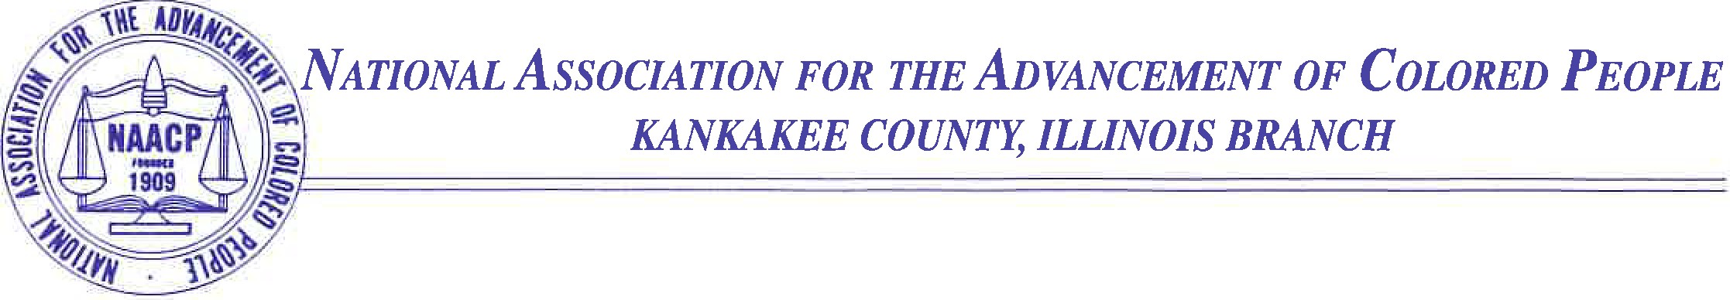

**FOR IMMEDIATE RELEASE**

**NAACP Illinois State Conference to Host 88th Annual Convention in Kankakee County**

**KANKAKEE, IL —** The NAACP Illinois State Conference will host its **88th Annual Convention** from **Friday, September 26, 2025, through Sunday, September 28, 2025**, at the **Quality Inn & Suites in Bradley, Illinois**. This year’s theme, *“The Fierce Urgency of Now,”* is inspired by the timeless message of Rev. Dr. Martin Luther King, Jr. and will guide a weekend of workshops, discussions, and events focused on advancing civil rights and social justice across Illinois.

The three-day convention will convene delegates, leaders, and community members from across the state for engaging **sessions, workshops, and keynote addresses**. The agenda is designed to reflect the NAACP’s mission to ensure political, educational, social, and economic equality for all people.

* **Friday, September 26** will begin with a **Labor Breakfast** featuring **Tim Drea, President of the Illinois AFL–CIO**, followed by the **Opening Plenary Session**. Afternoon workshops will explore issues including **Veterans Benefits, juvenile justice reform, and environmental climate justice**, with a focus on **Gotion Inc.’s sustainability efforts in Manteno, IL**.
* **Friday’s Advocacy Luncheon** will feature remarks from **Senator Patrick Joyce**, and additional workshops will include presenters such as **Dr. Stonewall McCuiston Jr.** on health disparities; **State’s Attorney Jim Rowe** and **Judge Marlow A. Jones** on trauma and the juvenile justice system; and **American Rivers** experts on climate-related flood risks impacting communities of color.
* **Saturday, September 27** begins with the **Women in the NAACP (WIN) Breakfast**, honoring *“Phenomenal Women with Hats & Boots on the Ground.”* The day’s workshops will span education reform, criminal justice, and community safety, featuring leaders like **Sheriff Michael Downey** and **Police Chief Schenita Stewart**. The evening’s **Freedom Fund Banquet** will be highlighted by a keynote address from **Rev. Dr. Michael C.R. Nabors**, President of the NAACP Evanston Branch.
* **Sunday, September 28** will close the convention with a **Delegates Breakfast, Worship Service, and Closing Plenary**, offering space for reflection and a collective call to action.

**Theodis Pace**, President of both the **Illinois State Conference** and the **Kankakee County Branch**, underscored the urgency of this year’s theme:

“Our theme, *‘The Fierce Urgency of Now,’* is more relevant than ever. This convention is a call to action. We must work together to confront the pressing issues facing our communities from health and education to criminal justice and environmental equity. We invite everyone to join us in this vital work.”

Delegates, NAACP members, and the public are encouraged to attend and participate in this powerful weekend of advocacy, networking, and community-building.

For registration details and additional information, please visit the **NAACP Illinois State Conference website** or contact the Kankakee County Branch directly.

**Contact:**  
Theodis Pace  
NAACP Kankakee County Branch  
Email: naacp3035@aol.com  
Phone: 815-953-9390

**657 E. Court St., Suite 205 • P.O. Box 1986 • Kankakee, Illinois 60901**

**815/932-0858 • Fax 815/932-2876 • E-mail:** [**naacp3035@aol.com**](mailto:naacp3035@aol.com) **•** www.kankakeecountybranchnaacp.org